Optimization Project

Max & Rachit

**Data:**

* <https://brunel.figshare.com/articles/dataset/Supply_Chain_Logistics_Problem_Dataset/7558679>
* <https://developer.uber.com/docs/businesses/data-automation/introduction>

**Resources:**

* 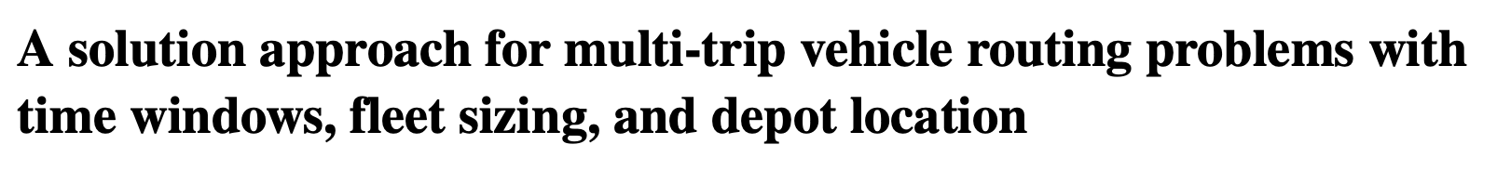
  + <https://onlinelibrary.wiley.com/doi/epdf/10.1002/net.22028>
* A picture containing text

  Description automatically generated
  + <https://www.reprintsdesk.com/userv3/fulltextreader.aspx>
* Text

  Description automatically generated with medium confidence
  + <https://ieeexplore.ieee.org/stamp/stamp.jsp?tp=&arnumber=9144213>

**Brainstorm:**

**Problem:**

* Amazon needs to deliver items using different modes (bikes, cars, trucks, etc.).
* Cars etc. come from outside the city to deliver items
* We have customer locations (demand nodes)
* We have warehouses (supply nodes)

**Data:**

**Analysis:**

**Insights:**

**Objective:**

**Constraints:**

* Number of vehicles of each type
* Satisfying demand at each node
* Supply at supply node
* Capacity of each vehicle

**Decision Variables:**

* Number of vehicles going from i to j of type k (x_ijk)

**Assumptions:**

* There is only one item type to constrain the volume